Lab 9: Rotary Pendulum Modeling

EEE4514

April 4, 2017

**Gabriel Stroe**

# Filtering

## Overview

The purpose of this lab is to configure the rotary pendulum system so that we can accurately see its angular position at any point in time. The focus of this lab is to configure this system so we can use it to drive the system in the next lab.

## Theory and Methods

In the beginning of the lab we set up the system so we can read both the rotary arm and the pendulum in degrees. This is a fairly straight forward conversion of 2*PI/512/4 based on the specifications of the servo motor.

This would give us a result in that would not cycle between -180 and 180 degrees. To fix this we add this modulus equation to the pendulum scope:



## Results

The first part of the lab was very easy to set up and our results are posted bellow:

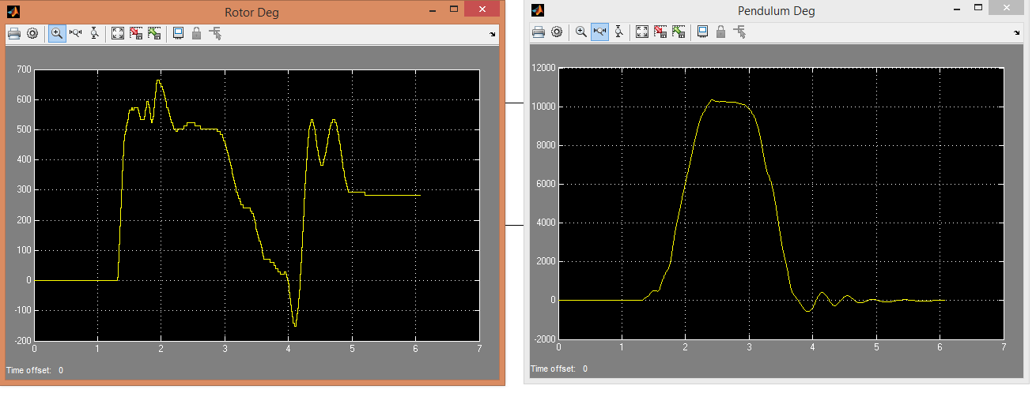

This shows the system as we raise and dropped the pendulum. Next we added a 0.5-volt unit step input and got the following results:

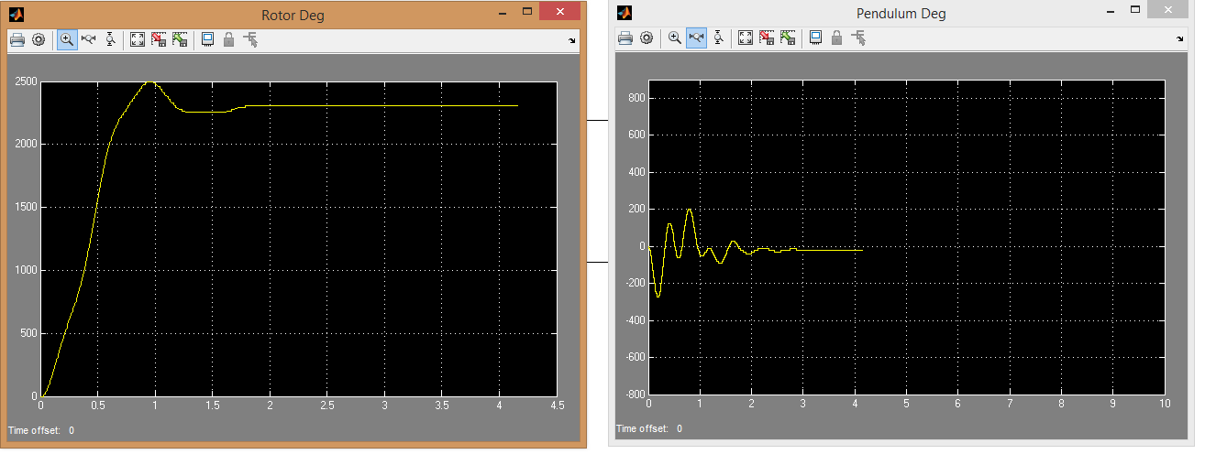

Lastly we added the modulus filter so we can see this loop back into position from – 3.14 to + 3.14

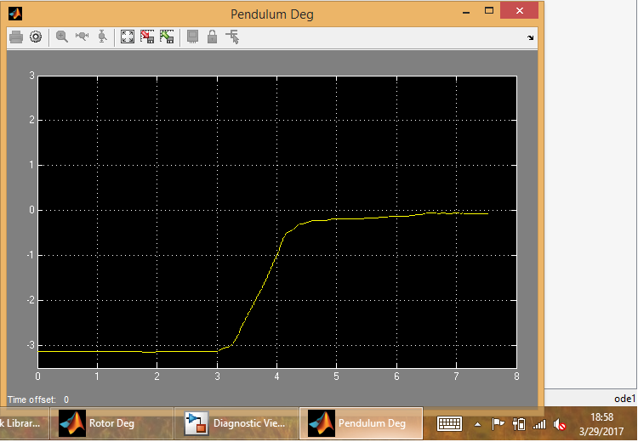

## Questions

1. Yes, they do match.
2. Yes, it adheres to the modeling conversions
3. The Modulus and Bias block moves the output so it can cycle between Pi and – Pi.

## Conclusion

This lab allowed us to configure this pendulum system so that we can balance the pendulum in a later lab. Now with the output of the system going from pi to – pi this can be fed back to the system so that it can balance while standing up.